Exercise 3:

1. docker run -d dockersamples/static-site

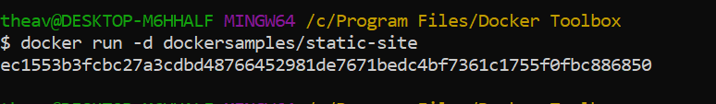

1. docker ps



1. docker stop docker rm

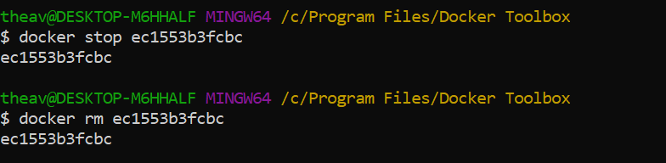

1. docker run --name static-site -e AUTHOR="Thea Van Kessel" -d -P dockersamples/static-site

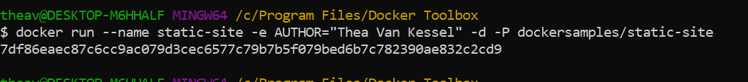

1. docker port static-site

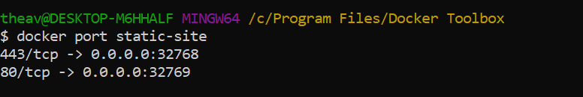

1. docker-machine ip default

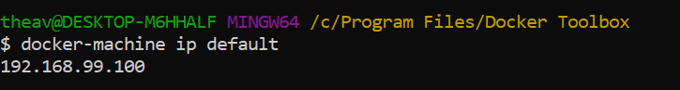

1. The running web page:

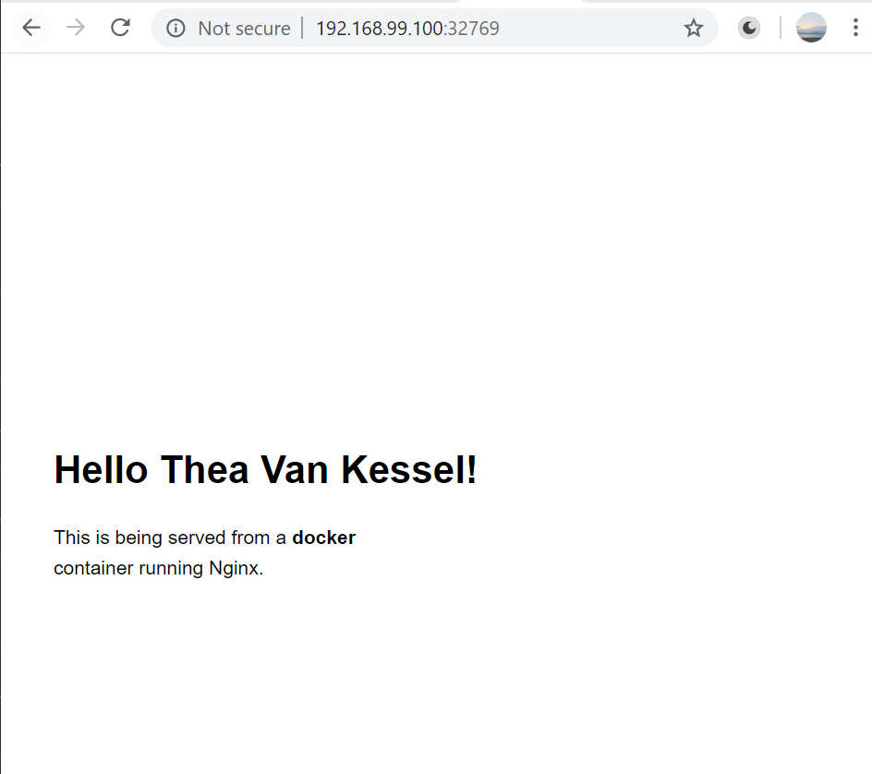

1. docker stop static-site

docker rm static-site

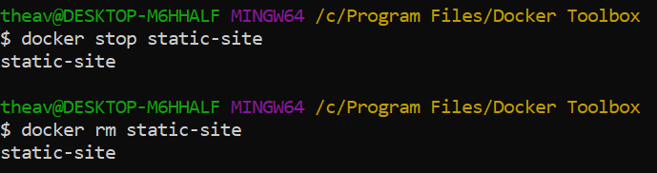

1. docker ps

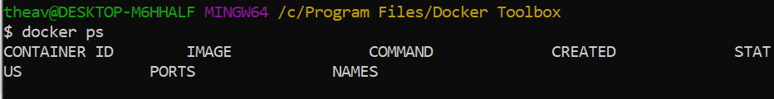

1. docker images

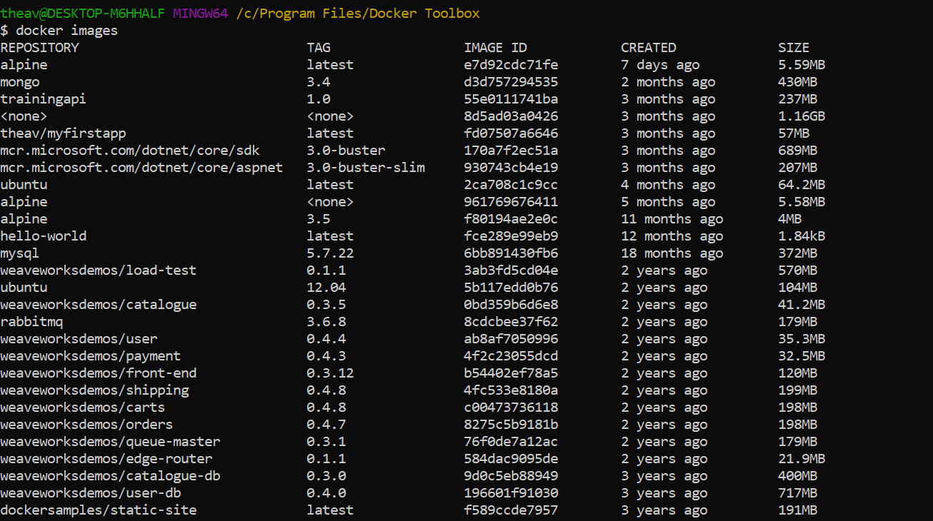

1. docker pull ubuntu:12.04

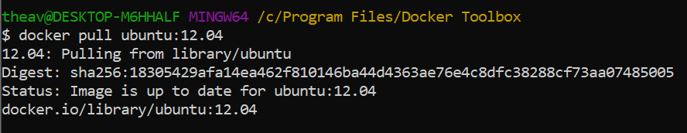

1. docker pull ubuntu

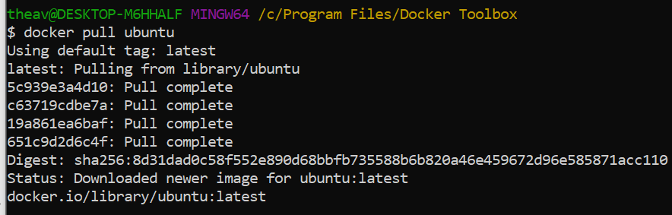

1. docker build -t theav/myfirstapp .

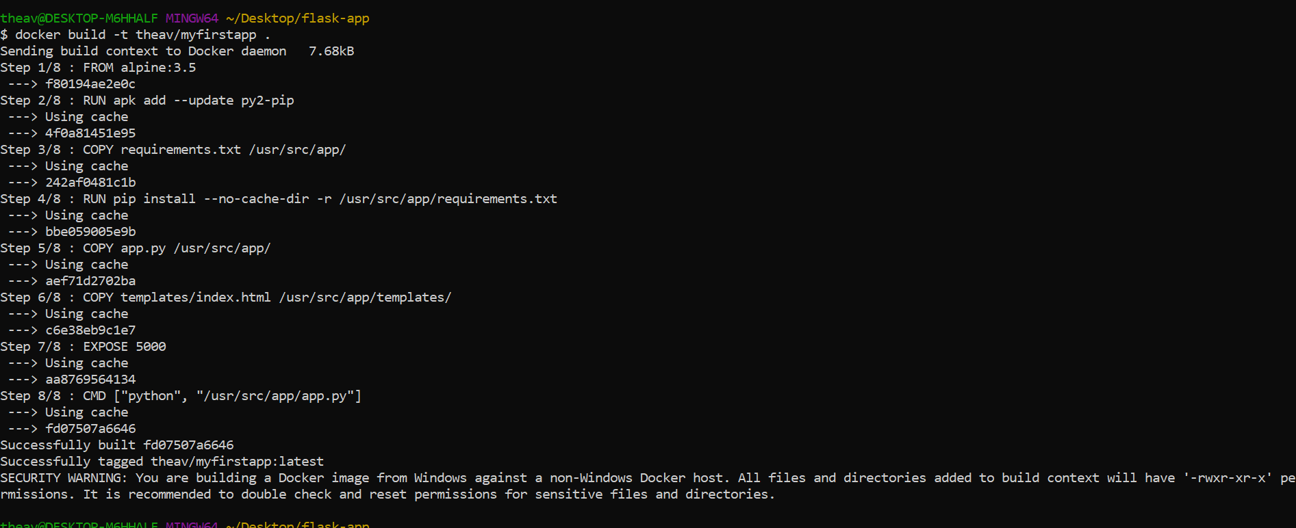

1. docker images

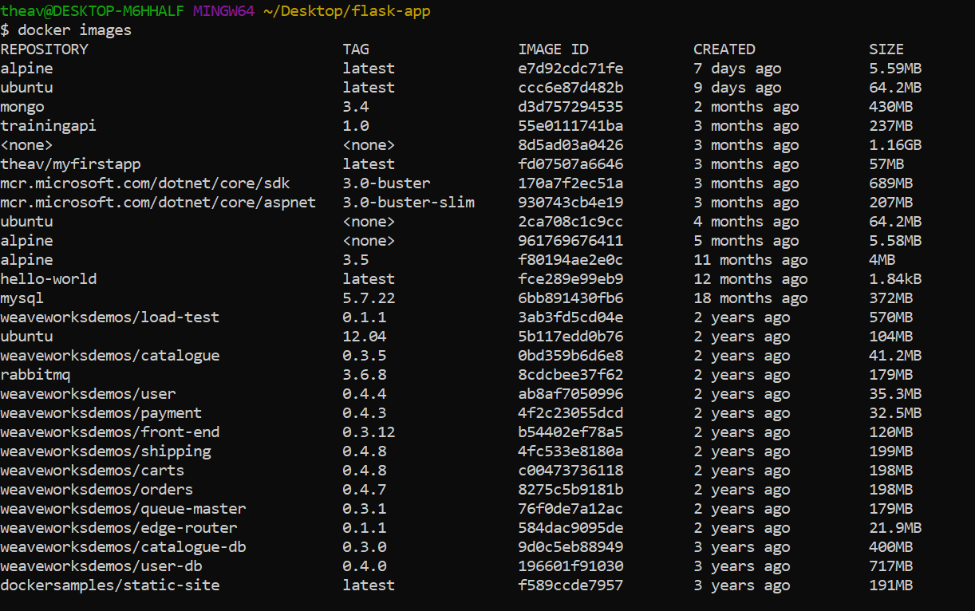

1. docker run -p 8888:5000 --name myfirstapp theav/myfirstapp

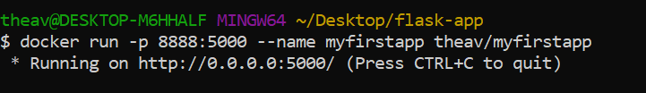

1. 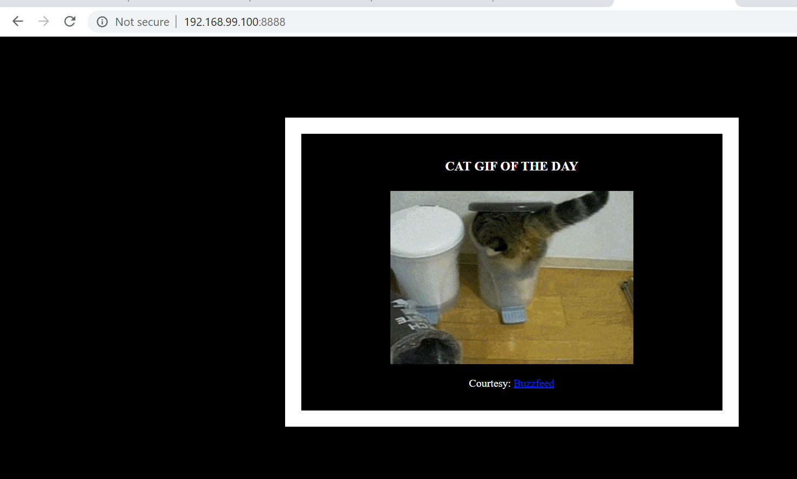
2. docker login

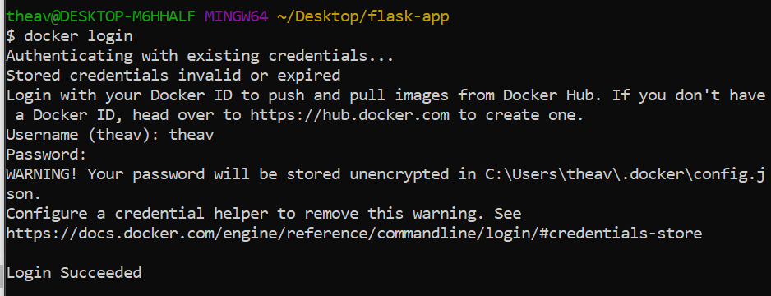

1. docker push theav/myfirstapp

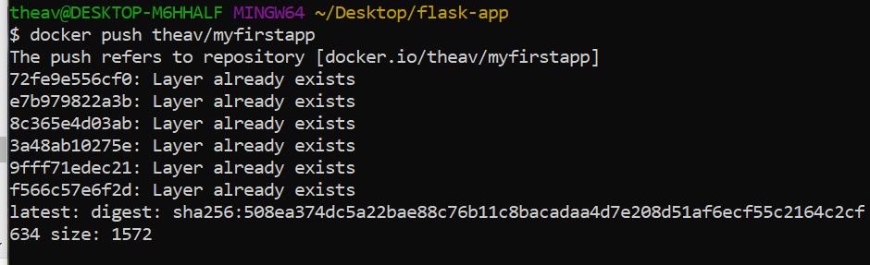

1. docker rm -f myfirstapp

